Now one another transform for feature is Mathematical transform and this are just some mathematical operation which we can apply on feature and are problem specific ofcourse.

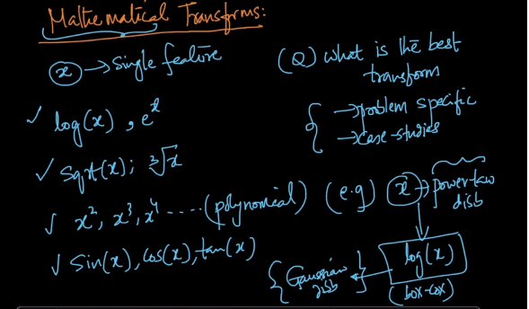

So for example if we know that our feature is power law distributed that we can use log(x) as our transform because we know that in most of cases log(x) converts power law distributions to Gaussian Distributions.

